**CNG KIT CYLINDER & PARTS MANGEMENT SYSTEM**

**OF**

**ENERGY ZONE**

**GROUP MEMBERS**

**MUHAMMAD UNAIS.17B-017-SE.SEM 1V SE-A**

**SHOAIB AHMED.17B-033-SE.SEM IV SE-A**

**HASSAN AHMED.17B-049-SE.SE A. SEM IV SE-A**

**ALI AKBAR.16B-056-SE. SEM IV SE-A**

**COURSE INSTRUCTOR**

**INSTRUCTOR NAME: USMAN WAHEED**

**TOPIC**

**BLACKBOX TESTING**

**USMAN INSTITUTE OF TECNOLOGY**

Contents

Control Testing 8

1. Textbox (ReadOnly, Alphanumeric, Numeric, Aplha) 8

Contributors 8

Purpose 8

Category: 10

Test case (input Based) 10

Test cases (step based) 12

Guidelines 14

2. Dropdown-Box List 15

Contributors 15

Purpose 15

Category 16

Test Cases (Input based) 16

Test Cases (Steps Based) 17

Guidelines 19

3. Button 19

Contributors 19

Purpose 20

Category 20

Test Cases (Steps Based) 20

Guidelines 24

4. Radio Button 24

Contributors 24

Purpose 24

Category 25

Test Cases (Input based) 25

Test Cases (Steps Based) 25

Guidelines 26

5. Image 26

Contributors 26

Purpose 26

Category 27

Test Cases(Input based) 27

Test Cases(Steps Based) 28

Guidelines 29

6. Table or Grid 29

Contributors 29

Purpose 29

Category 30

Test Cases (Steps Based) 30

Guidelines 30

References 31

Requirements and Strategy: 31

Interface Testing 32

**Vendor Order Interface** 32

Contributors 32

Purpose 32

Test cases (step based) 32

Guidelines 35

References 36

Requirements and Strategy: 36

Application Testing 37

Contributors 37

Purpose 37

Develop a Driver (for single interface) 37

Develop a Driver (for transactional interface) 37

Select any single interface that contains more than 5 controls of at least three different controls and any two transactional interfaces and then develop their test cases using steps mentioned below

* Place correctly filled interface

**

* Mention list of 3 valid values of each control in a table

|  |  |  |  |
| --- | --- | --- | --- |
| Control name | Valid value 1 | Valid value 2 | Valid value 3 |
| Checkbox | True | False |  |
| Button | Onclick | Form values | Id e.g. 11, 1, or1025 etc. |
| Dropdown Box | Item names e.g. CNG Kit, CNG Filling Plug etc. | Customer Names e.g. Hassan, Ahmed or Aamir | Vendor Names e.g. Suzuki |
| Table or Grid | Data from database | Inputting the data of form |  |
| Numeric Textbox | 10 or 20 | 35550 | 700000 |
| Read-only Textbox | 20-Jul-2020 | 42101-4393979-5 | 0347-6797669 |
| Image |  |  |  |

# Control Testing

* based on testcases prepared in earlier assignment, test each control on that interface and also support requirement associated with that control, and mention strategy to test control level testing in steps

### Textbox (ReadOnly, Alphanumeric, Numeric, Aplha)

### Contributors

Hassan Ahmed Siddiqui, hassansiddiqi0@gmail.com, Usman Institute of technology

### Purpose

Textbox is a input control that it is a rectangular box which is placed on the interface for taking an input. It is the most common control found in almost any software programs. Textbox is usually used as enter data in it, can take different types of input such as alphanumeric, numeric or alphabetic data in it and can also be formatted according to requirements. On clicking the textbox, the cursor flashes indicating the text or data can be entered now. Text box is used to enter and retrieve data to backend database or can contain in some case default values.

**Example**

Figure 1: Textbox for alpha value

Figure 2: Read-Only Textbox for alphanumeric value

Figure 3: Read-Only Textbox for numeric value

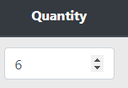**s**

Figure 4: Textbox for numeric value

Figure 5: Textbox for date value

**Figure 1:**  This box is used to search for data through vendor shop name.

**Figure 2:** This box is used for showing the CNIC of customers, which is a read-only textbox.

**Figure 3:** This box is used to show the price per item to know its details. It is also a read-only textbox

**Figure 4:** This textbox is used in grid to enter the quantity of items. It is a number textbox

**Figure 5:** This textbox is for selecting dates for item delivery, it is date textbox

### Category:

Input Control

### Test case (input Based)

**Read-only:**

1. Do any of the pre-populated value are displayed as per requirement?

|  |  |  |  |
| --- | --- | --- | --- |
| Test case Name | Input | Output | Valid /Invalid |
| Pre-Populated values | Values form database such as Vendor Name: Anas, Shariq etc |  | Valid |
| 10 or 20 i.e. quantity |  | Valid |
| Not loading any values |  | Invalid |

1. Do the formatting in the read-only textboxes are according to the requirements?

|  |  |  |  |
| --- | --- | --- | --- |
| Test case Name | Input | Output | Valid /Invalid |
| Correct format | Value from database;4210-45303354-5 |  | Valid |
| 4210-45303345 |  | Invalid |

1. Does the textbox show the calculated value of the after value entered in other textboxes by triggering an event?

|  |  |  |  |
| --- | --- | --- | --- |
| Test case Name | Input | Output | Valid /Invalid |
| Trigger Event |  |  | Valid |

**Enabled Textboxes:**

1. Do the textboxes accept values equal and between its min and max limit?

|  |  |  |  |
| --- | --- | --- | --- |
| Test case Name | Input | Output | Valid /Invalid |
| Quantity min and max limit | Here the limit for quantity is 15 so, 5 |  | Valid |
| 13 |  | Valid |
| 18 |  |  |

1. Do the leap years are validated correctly & do not cause errors/miscalculations?

|  |  |  |  |
| --- | --- | --- | --- |
| Test case Name | Input | Output | Valid /Invalid |
| Leap Year | 29-Feb-2020 |  | Valid |
| 29-Feb-2021 |  | Invalid |

1. Do the month code 01 and 12 are validated correctly & do not cause errors/ miscalculations?

|  |  |  |  |
| --- | --- | --- | --- |
| Test case Name | Input | Output | Valid /Invalid |
| Month code | 17-07-2020 |  | Valid |
| 17-00-2020 |  | Invalid |
| 17-13-2020 |  | Invalid |

### Test cases (step based)

**Read-only:**

1. Does the read-only textbox cannot be edited?

By clicking on the text, performing other features of the interface even after the textbox remains with read-only property, if not there is an error or bug.

1. Does the cursor display on the disabled Textbox?

Take the cursor on the textbox and see whether it is displayed or not, if not then it is working properly.

1. Does the SHIFT and Arrow select characters and is the selection possible with mouse Double Click for all text in textboxes.

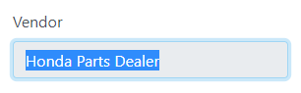

By double clicking the whole text is selected and also by using the shift and arrow keys.

**Enabled Textbox:**

1. Does date textbox show a calendar on clicking on its calendar icon? A screenshot of a cell phone

   Description automatically generated

After clicking the icon it shows a calendar to select a date from it.

1. Does the function displayed in calendar working correctly?

After selecting the feature it seen that whether it is working properly or not.

1. Does it allow to select the values from the calendar?

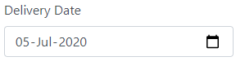

1. Does the cursor start blinking when get focused on the numeric textbox?

### Guidelines

**Read-only:**

1. Does the textbox have the enabled or disabled property as per the requirement?
2. Do the Textbox should be enabled to enter value or remained to be with only read-only values, check for conditions?
3. Do the textboxes are greyed out to show their property?
4. Do check for combination of alphabets, numeric, signs and special characters.
5. Does the value coming from DB is correct and populating correctly?
6. Does the Database accept “Redundant” values?
7. Does the alignment of Textbox and Text associate with Textbox are proper as per other controls on window?
8. Do the textboxes have the correct “Text” associated with them?
9. Does its pre-population any value or BLANK value for textboxes as per requirement?

**Enabled Textbox:**

1. Does it show for RED asterisk for mandatory fields? (as per requirements)
2. Does the coming from DB is editable or not?
3. Does the alignment of Textbox and Text associate with Textbox are proper as per other controls on window?
4. Does century change is validated correctly & does not cause errors/miscalculations? Verify it.
5. Do the dates Feb. 28, 29, 30 are validated correctly & do not cause errors/miscalculations?
6. Does its pre-population any value or BLANK value for textboxes as per requirement?

### Dropdown-Box List

### Contributors

Hassan Ahmed Siddiqui, [hassansiddiqi0@gmail.com](mailto:hassansiddiqi0@gmail.com), Usman Institute of Technology

### Purpose

A drop-down list is a graphical control element, which is quite similar to a list box, that allows the user to select a value from a list of values in the box. When a drop-down list is inactive, it displays the default value or pre-selected value. When activated by clicking it, it drops down a list of values, from which the user may select one, as the user selects a value, the control reverts back to its inactive state, displaying the only selected value. It is mainly used to show data in other textboxes according to the data selected in the

**Example**

Figure 1: Dropdown List for Items

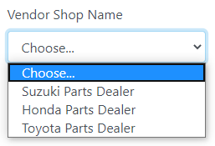

Figure 2: Dropdown List for Vendor Shop Name

**Figure 1:** The figure gives the dropdown list of the items available.

**Figure 2:** This provides the name of the shop the vendor in a dropdown List.

### Category

Graphical control

### Test Cases (Input based)

1. Does it display the default value that should be displayed, or it should be BLANK?

|  |  |  |  |
| --- | --- | --- | --- |
| Test case Name | Input | Output | Valid /Invalid |
| Default Values | Pre-populated Value |  | Valid |
| Blank value |  | Valid |

1. Do the mandatory field can accept BLANK value?

|  |  |  |  |
| --- | --- | --- | --- |
| Test case Name | Input | Output | Valid /Invalid |
| Blank value | Select a value from list |  | Valid |
| Blank value |  | Invalid |

1. Does it contain the correct or incorrect data?

|  |  |  |  |
| --- | --- | --- | --- |
| Test case Name | Input | Output | Valid /Invalid |
| Correct or Incorrect Data | Load data for items |  | Valid |
| Load data for Vendor |  | Valid |
| Load data for items |  | Invalid |

### Test Cases (Steps Based)

1. Does the click on the arrow of the control display the list?



After clicking the list is displayed.

1. Does the list shown not empty or empty?



If the list appears to be empty, then the data is not being loaded.

1. Does entering the first letter of the options in control and value should get selected?

By pressing the character, A on the keyboard;

Ac kit is selected.

1. Does the data change for other textboxes with the change in the selection of the dropdown list according to the data?

By selecting an option from the list, it shows data according to the selected option.

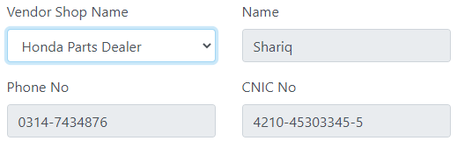

Even for the Item dropdown list. 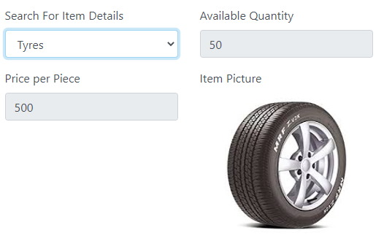

1. Does it allow to delete selected option in control?

No it doesn’t allow the a selected option to be deleted.

### Guidelines

1. Does the list contain number of values to display the “Scroll” option? And it should be working.
2. Does the alignment of list is associated with control?
3. Do all the dropdown list on this screen are sorted correctly? Alphabetic sorting is the default unless otherwise specified.
4. Do the names in the dropdown list boxes are not abbreviations or cut short?
5. Does it display the appropriate sign (as arrow) over dropdown list?

### Button

### Contributors

Hassan Ahmed Siddiqui, [hassansiddiqi0@gmail.com](mailto:hassansiddiqi0@gmail.com), Usman Institute of Technology

### Purpose

A button is an very common interactive element that is used in every application there is, it enables us to get the expected and interactive feedback for every event performed from the system. Basically, a button is a control that allows a user to directly communicate with the with the application allows you to perform action on it and send the necessary commands or trigger events to achieve a particular goal.

**Example**

Figure 1: Add vendor Button

Figure 2: Add row Button

Figure 3: Generate Invoice and Cancel Buttons

Figure 4: Submit and Generate Button

**Figure 1:** Add vendor button goes to Vendor adding page to create a new vendor.

**Figure 2:** Add row triggers an event to add new row to the table or grid to enter more data

**Figure 3:** Generate invoice bill of the vendor order and save it to the details to database. Cancel button cancels the transaction and navigates back to the order list.

**Figure 4:** Submit and Generate button save the invoice details and navigates back to order list to show the add data.

### Category

Graphical Control

### Test Cases (Steps Based)

1. Does the default button work correctly?

Before clicking the button, filling the data and leaving to some places blank.

After clicking the Generate invoice button it showed the errors went saving the data.

1. Do the events occur after clicking on the buttons?

Before clicking the Add row button, to add new row to much more data.

After clicking the button a new row is added to the grid.

1. Does the button display become “Highlighted” with hovering of mouse cursor on the control?



Before hovering the mouse.

After hovering we can see that they are highlighted.

1. Do the appropriate information displayed as per requirement on hovering of mouse cursor?

On hovering these buttons show information and other buttons also.

1. Does on the pressing the Command button results in uncorrectable data e.g. closing an action step, there should be a message phrased positively with Yes/No answers where yes results in the completion of the action. Does it show it?

### Guidelines

1. Does the button has Enable or disable property of the control?
2. Do all the command buttons are all of similar sizes and shape, and same font, verify?
3. Does the screen have a specified default button?
4. Do the buttons have alignment with other controls on the window?
5. Do the label on the control editable? They should not be editable.
6. Do the events are successfully executed with single click, Double click and more than double click on the button
7. Does the “Highlighted” button control accept click event with keyboard “Enter” key?

### Radio Button

### Contributors

Hassan Ahmed Siddiqui, [hassansiddiqi0@gmail.com](mailto:hassansiddiqi0@gmail.com), Usman Institute of Technology

### Purpose

Radio buttons may be arranged in a group of two or more and A radio button or option button is a graphical control that allows the user to only select one of the predefined set of mutually exclusive options, it allows more than one or no item to be selected and for the unselected state to be restored.

**Example**



Figure 1: Radio Button

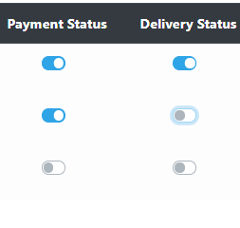

Figure 2: Custom Radio Button

**Figure 1:** The radio button help us to select one and only one predefined option.

**Figure 2:** The custom radio button is the button used to show pre-stored values from the database.

### Category

Graphical control

### Test Cases (Input based)

1. Do the pre-populated checkbox whether they are correct or not from the database?

|  |  |  |  |
| --- | --- | --- | --- |
| Test case Name | Input | Output | Valid /Invalid |
| Pre-populated | Amount Paid |  | Valid |
|  | Amount Paid |  | Invalid |

### Test Cases (Steps Based)

1. Do we cannot select more than one radio buttons?



Only option can be selected at a time, can also bee seen in the grid or table.



1. Does on mouse click, space bar and enter key press should change property of radio button from checked to unchecked or vice versa?





After pressing space or clicking enter it is unchecked.

### Guidelines

1. Do an appropriate label for each radio button?
2. Does an appropriate event associated with radio button property change if there are any?
3. Do the disabled radio button not be editable?
4. Does the alignment is proper with other controls in window?

### Image

### Contributors

Hassan Ahmed Siddiqui, [hassansiddiqi0@gmail.com](mailto:hassansiddiqi0@gmail.com), Usman Institute of Technology

### Purpose

Image controls used as icons, informational graphics, and charts will support the Image control type. Controls used as background or watermark images will not support the Image control type.

Images are UI components that allow you to display a picture, such as an icon or logo in your app. Image properties control the appearance and behavior of an image. Use dot notation to refer to a specific object and property.

**Example**

Figure 1: AC Kit Picture

**Figure 1:** This shows what is in the “Ac-kit” that is selected.

### Category

Image control

### Test Cases(Input based)

1. Does the correct is being loaded from the database according to the item selected in the drop down list.

|  |  |  |  |
| --- | --- | --- | --- |
| Test case Name | Input | Output | Valid /Invalid |
| Image Loading | An item selected such as tyre |  | Valid |
|  | Tube |  | Valid |
|  | Item selected that is not in database |  | Invalid |

### Test Cases(Steps Based)

1. Does it have option of zoom in and zoom out available?

First select an option from the Item Details combo box.

As we can see that there is no option of zoom in and zoom out after loading the image.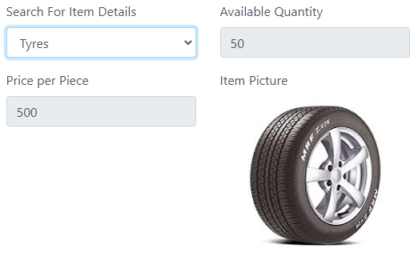

1. Does the image have poor quality and blurring it?

By zooming in using the web zoom feature to enlarge object will help us to see whether the is image has a good or poor quality.



As the image loaded has a good quality.

### Guidelines

1. Does the same image should get displayed either by scan or by import?
2. Does the correct image is being loaded every time the same item selected?

### Table or Grid

### Contributors

Hassan Ahmed Siddiqui, [hassansiddiqi0@gmail.com](mailto:hassansiddiqi0@gmail.com), Usman Institute of Technology

### Purpose

Table controls contain rows and columns of text and optionally also row headers and column headers. It is mostly used to display the stored data and other times used to input the values of in the database.

**Example**

Figure 1: Table or grid of Vendor order

**Figure 1:** Table or grid for the items to be entered with quantity for the order.

### Category

Table control

### Test Cases (Steps Based)

1. Do we can edit the default value?

We can only edit the values of the first as they are enabled.

1. Does the enable textboxes and dropdown list in the grid are editable?

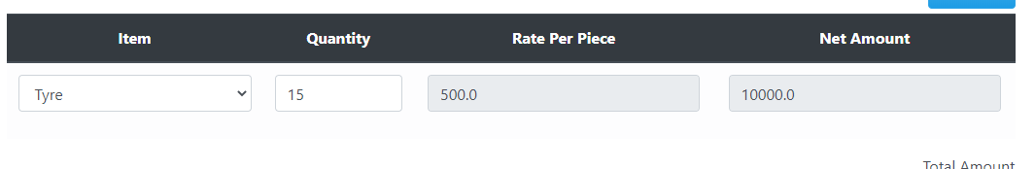

1. Does the data in the disabled textboxes auto-filled correctly?



As the last column of the net amount is auto-filled correctly by multiplying the 2 & 3 columns.

### Guidelines

1. Does the grid have default value?
2. Does the appropriate label for each column in grid control and a heading present in the entire grid control?
3. Do the disabled grid control clickable? It should not be clickable.
4. Do the textboxes and dropdown list in the grid are enabled or disabled?

### References

1. Graphical UI Testing Checklist. [www.raveinfosys.com/Doc/Web%20App%20UI%20Testing%20Checklist%20-%20Web%20App%20UI%20Checks.pdf](http://www.raveinfosys.com/Doc/Web%20App%20UI%20Testing%20Checklist%20-%20Web%20App%20UI%20Checks.pdf).

### Requirements and Strategy:

Here the requirements required for the testing the controls is the data we need that is associated with each textbox, dropdown list, radio button, grid and images and also what are the things requirement of the user are they being full filled or not.

The strategy is to check the every possible value for the textboxes with the designed testcases and to check all the functionalities are working properly with any error or bug, also the data that is being received from the database in the correct format to the associated control.

# Interface Testing

* based on testcases prepared in earlier assignment, test each interface, and also support requirement associated with that interface, and mention strategy to test each interface level testing in steps

## **Vendor Order Interface**

### Contributors

Hassan Ahmed Siddiqui, [hassansiddiqi0@gmail.com](mailto:hassansiddiqi0@gmail.com), Usman Institute of Technology.

### Purpose

The purpose of this interface is to make transactions and to record transactions of the Vendor Order made for the restocking of the items and to generate their invoice and save it to the database, so that can keep track of the record of the when will the deliveries be made and is there any payment reaming to be made or not.

### Test cases (step based)

1. Do the error and validation messages are displayed correctly?

The validation messages are being showed. Also, after correcting the value confirmation feedback is also being shown.

1. Does the autofill function working it is expected and that there are no UI issues?

All the gray textboxes are auto-filled by some events that are being triggered.

1. Do the elements in the dropdown are not overlapping? They should not be.

As the elements are not overlapped.

1. Dos the site logo visible and clickable?

By clicking the logo or name it navigates to the starting page of website.

### Guidelines

1. Does the Font styles - Font size, color, and family are same in the interface?
2. Do the images are not breaking and don’t have any watermarks?
3. Do the label text is clearly readable?
4. Do the elements are not breaking or distorted on different browsers and screen resolutions?
5. Does there any spelling mistakes in the field labels and web page headings?
6. Do the disabled fields are not accepting any input?
7. Do the links are visible and distinguishable from the other text such as the navbar links?
8. Does there any unnecessary blank spaces between the elements on the web page?
9. Do the horizontal and vertical scrollbars are appearing wherever necessary?
10. Does the web elements are not overlapping anywhere on the web page?
11. Does there no broken links on the web page? There should not be any.

### References

1. qed42. “UI Testing Checklist.” *QED42*, [www.qed42.com/blog/ui-testing-checklist](http://www.qed42.com/blog/ui-testing-checklist).

### Requirements and Strategy:

The requirements are the interfaces which needs to be tested and data associated with each control that are in the interface that is being tested. The requirement of the user is required as the develop interface is full filling the needs of the user or not.

Strategy is to test every part of the interface that is working as a single entity in the testing. The fonts, images, icons, and every feature that is added to the interface is to be tested according to the testcases developed. This will surely make our interface error and bugs free.

* based on testcases prepared in earlier assignment, test application Workflow and also support requirement associated with that workflow, and mention strategy to test application level testing in steps

# Application Testing

### Contributors

Hassan Ahmed Siddiqui, [hassansiddiqi0@gmail.com](mailto:hassansiddiqi0@gmail.com), Usman Institute of Technology.

### Purpose

The purpose of data validation is to detect and then verify any data values that may not represent actual air quality conditions at the sampling station. Effective data validation procedures usually are handled completely independently from the procedures of initial data collection. Moreover, it is advisable that the individuals responsible for data validation not be directly involved with data collection.

* describe how you will develop driver for single interface, transactional interface

# Develop a Driver (for single interface)

1. We need to check what data from the database is to be used in this interface and excluding the other data that irrelevant for this transactional interface.
2. Develop the interface whether it is a transactional or single in a way that their required data is being provided to them without depending on the other interfaces.
3. The features or functionalities provide in each of the interfaces is to be present in that driver and they should be working properly and efficiently.
4. The interface layout should not be hindered by it opening in a different application or in a different web browser.
5. The color theme, textboxes, dropdown list, checkboxes and other control should be aligned according to the requirements.
6. For a single interface only the function or feature like the CRUD will be developed for its own transactions.
7. The function mentioned in the sixth point are to be developed in way that they can be attached to same interface as an external source and perform their work properly.
8. The Interface developed may work as a API that can be attached to any application.

# Develop a Driver (for transactional interface)

1. We need to check what data from the database is to be used in this interface and excluding the other data that irrelevant for this transactional interface.
2. Develop the interface whether it is a transactional or single in a way that their required data is being provided to them without depending on the other interfaces.
3. The features or functionalities provide in each of the interfaces is to be present in that driver and should be working properly and efficiently.
4. The interface layout should not be hindered by it opening in a different application or in a different web.
5. The color theme, textboxes, dropdown list, checkboxes and other control should be aligned according to the requirements.
6. As for the transactional interfaces there may be some single interface functionalities attached to it, to perform its features correctly and fully.
7. The single interface like Add Vendor its functionalities should be developed as a CRUD module and the Transactional interface like Vendor Order’s functionalities are to be developed by attached the single interfaces required for it.
8. Develop these functionalities as an API to work as a service and run these on the interfaces check whether they are working properly or not.
9. Similar doing the process to develop another interface.

* propose the tested interfaces for other than developed environment (GUI, Web, mobile) with filled data.

These are the two proposed prototypes in the GUI based format.